Curriculum Vitae

Jorge L. Infante, M.D.
ABEM Certified Emergency Medicine

Infante Emergency Services, LLC
905 Columbus Blvd.
Coral Gables, FL 33134
(843) 655-5622
jorge@infantemedicalservices.com
Website: www.infantemedicalservices.com

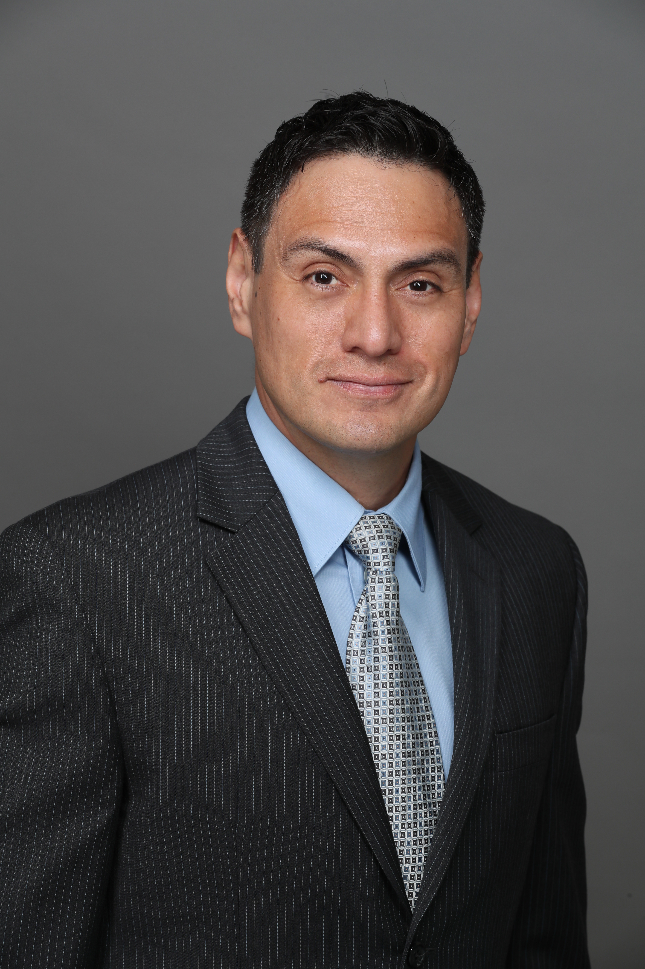

Summary of Expertise

Residency trained at Hennepin County Medical Center, Minneapolis. Board certified for over fifteen (15) years through the American Board of Emergency Medicine. Served as a Board Member of the South Carolina Chapter of Emergency Physicians. Experienced in implementing quality assurance protocols and risk-mitigation protocols; educating fellow board-certified physicians, residents, medical students and advance practice provider students; and partnering with numerous hospital administrations and other departments to enhance patient care, efficiency and quality. Competently and compassionately treated well over 45,000 patients.

Areas of Expertise
Anaphylaxis/Allergic Reactions
Asthma
Airway Management
Appendicitis
Aortic Emergencies (Aneurysm and Dissections)
Bowel Obstruction
Bowel Infections
Cardiac Arrest and Resuscitation
Diabetic Ketoacidosis
Deep Vein Thrombosis
Drug Intoxication/Overdose
Dysrrhythmias
Ectopic Pregnancy
Epidural Abscess/Discitis/Osteomyelitis of Spine
Gastrointestinal Hemorrhage
Genitourinary Emergencies
Intracranial Hemorrhage
Myocardial Infarction
Ocular Emergencies
Ovarian Torsion
Pelvic Inflammatory Diseaes
Pneumonia
Psychiatric Emergencies
Pulmonary Embolism
Sepsis
Soft Tissue Infections
Toxicology
Ultrasound Guided Procedures
Emergent Fracture/Dislocation Procedures
Vascular Access Procedures
Tube Thoracostomy

Focused Expertise:
EMTALA Violations
Point of Care Ultrasound
Critical Care
Airway Stabilization techniques.

PROFESSIONAL EMPLOYMENT
Marion County Medical Center 07/2005 – 04/2007
Emergency Department Staff Physician

Marion County Medical Center 07/2006 – 04/2007
Assistant Medical Director
Emergency Department Staff Physician
-Prepared and implemented the protocol for ultrasound credentialing for Marion County Medical Center Emergency Department physicians: Conducted didactic lessons and practical training.
-Oversaw/Directed/Designed the implementation of bedside registration
- Oversaw/Directed/Designed the implementation of airway management adjuncts: ILMA and Bougie Introducer
-Successfully Lobbied state legislators with Marion County Medical Center administration in regards to the lack of inpatient psychiatric patient resources.

Grand Strand Regional Medical Center 05/2007 – 06/2008
Emergency Department Staff Physician
-Prepared proposal for Bedside Ultrasound in the Emergency Department.
-Presented data to GSRMC Trauma Committee regarding use of the Focused Abdominal Sonographic Test in the management of the trauma patient, which resulted in the implementation of a new standard of care.

The Regional Medical Center of Orangeburg and Calhoun 07/2008 – 02/2010
Emergency Department Staff Physician

Conway Medical Center - Conway Emergency Group 02/2010 – 10/2017
Emergency Department Staff Physician
-Prepared narcotic analgesic policy used in the Emergency Department.
-Mid Level Provider Committee Member: Development of mid-level provider program in our company including quality control and administrative protocols
-Information System Committee: Analysis of Best of Breed vs Enterprise programs for the department
-Director of Advance Practice Providers(NP/PA) 01/2016 – 02/2017
-Prepared protocols and policy regarding adequate supervision, further education and training of advance practice providers and quality assurance
-Administrative management, scheduling too.

Locum Tenens Work (Emergency Medicine Staff Physician):
Providence Hospitals Downtown and Northeast 01/2011-03/2011
Downtown and NE Campuses– Columbia, SC

Aiken Regional Medical Center – Aiken, SC 01/2012- 12/2013
07/2017- 10/2019

St Francis Bon Secours – Greenville, SC 10/2013-01/2014

McCleod Seacoast Hospital – Little River, SC 10/2013-10/2019

Mcleod Loris Community Hospital - Loris, SC 10/2013-10/2019

Grand Strand Regional Medical Center-Myrtle Beach, SC 12/2015-11/2018

Conway Medical Center - Conway, SC 10/2017-10/2019

Waccamaw Community Hospital - Murrell’s Inlet, SC 05/2017-10/2019

Aventura Hospital and Med Center - Aventura, FL 06/2017-04/2019

Lawnwood Regional Medical Center – Ft Pierce, FL 12/2017-10/2019

Advent Health of Ocala – Ocala, FL 11/2017-09/2020
Previously: Munroe Regional Medical Center
Previously: Florida Hospital of Ocala

Poinciana Medical Center - Kissimmee, FL 07/2018-10/2019

Citrus Memorial Hospital - Inverness, FL 10/2018-09/2020

Christus Health System - Louisiana 02/2019-09/2020
St Frances Cabrini - Alexandria
Bossier/Highland - Shreveport
Ochsner/St Patrick - Lake Charles

The Regional Medical Center - Orangeburg, SC 04/2019 -09/2020

EDUCATION
B.S. University of Miami 05/1998
Coral Gables, Florida
Major: Microbiology
Minor: Chemistry
Cum Laude

M.D. University of Miami School of Medicine 05/2002
Miami, Florida

Post Graduate Training/Residency 07/2005
Hennepin County Medical Center
Department of Emergency Medicine
Minneapolis, Minnesota

American Board of Emergency Medicine Certification 06/2007- 12/31/2027

ACLS, ATLS, PALS Certification

LICENSES
Minnesota Board of Medical Practice 06/2002 - 06/2005
Residency Permit #16495

South Carolina Board of Examiners 09/2005 – 06/2021
License # SC 27835
State Controlled Substance
SC DHEC License # 20-27835

Florida Board of Medical Examiners 09/2016 - 01/2021
License # ME129975

Louisiana Board of Medical Examiners 09/2018 – 10/2019
License #310829
State Controlled Substance
Louisiana CDS.053337

West Virginia Board of Medical Examiners 05/2019 – 06/2020
License # 29002

DEA (SC) FI8186923 03/2019 - 11/2021
DEA (FL) FI6571930 10/2019 – 11/2022

HONORS AND AWARDS

Medical School
▪Honors Designation: Trauma Surgery and Psychiatry, 2000
▪Thomas Brown McClelland Academic Scholarship Recipient, 1999-2001
▪Jackson Memorial Hospital Volunteer Service Award, 1998
▪Medical Scholars Program (7yr Accelerated B.S./M.D. Program- University of Miami),
1997
▪American Cancer Society Research Fellowship Recipient, 1999
▪Peruvian American National Association's TUMI Award - Outstanding Student of the
Year, 2001

Professional
Elected to Board of Directors for the South Carolina Chapter – American College of Emergency Physicians, 2007-09

LANGUAGES
Spanish - Written and Spoken, Fluent

PROFESSIONAL SOCIETIES
▪American Medical Student Association
▪National Hispanic Medical Association
▪Peruvian American Medical Association
▪American Society of Hematology
▪American College of Emergency Physicians
▪Society of Academic Emergency Medicine
Professional Teaching Activities
- LLSA Instructor for South Carolina American College of Emergency Physicians 2011
- ACLS Instructor

▪American Academy of Emergency Medicine

RESEARCH EXPERIENCES
Hennepin County Medical Center. Minneapolis, MN. Study to analyze the effect of Body
Mass Index (BMI) and Percent Body Fat (PBF) on acute pain perception of a
standardized stimulus in the emergency department. 2003-2005.

Hennepin County Medical Center. Minneapolis, MN. Senior Resident Project: Study of
factors, both economic and political, influencing the current state of the medico-legal
crisis affecting health care providers in the United States. 2004

Microbiology Department. University of Miami School of Medicine. Miami, FL: 2001-
2002. Inhibition of hematopoietic regulatory genes and other preliminary work for
knockout mice development.

Ryder Trauma Center. University of Miami School of Medicine. Miami, FL: 2001-2002
(see below)

American Cancer Society Fellowship. University of Miami School of Medicine. Miami,
FL: 1999 (see below)

NYU MSUCRP Fellowship. NYU Medical Center. N.Y., N.Y.: 1997 (see below)

PUBLICATIONS/PRESENTATlONS
Oral Presentation: "The use of triple contrast CT as a tool for triage of patients with stab wounds to the back and flank: a literature review" - Trauma Surgery
Conference, Ryder Trauma Center, Miami, FL. 2001

Publication: “Screening, cloning and characterization of novel transcription factors involved in blood cell development”. Experimental Hematology - EXP HEMATOL 01/2000; 28(7):108-108. Ronald Nachtman, James M Abdullah, Jorge L Infante, Ronald Jurecic

Poster Board Presentation: "Cloning and characterization of Vulcan, a novel zinc
finger gene with developmentally regulated expression during differentiation of
hematopoietic stem cell and progenitors into lymphoid and myeloid lineages" - 4151
Annual Convention of the American Society of Hematology, New Orleans, LA. 1999

Oral presentation: "Influence of birth order on risk for coronary artery events" -
NYU School of Medicine Summer Research Symposium. TischHospital. NewYork,
N.Y. 1997

Media Appearances:

- Jorge Infante. Interview with Connie Fossi ‘Life and Death Decisions Done Daily’: NBC 6 Survey Shows Growing Concerns Among Medical Staff Battling COVID-19. NBC. Channel 6 WTVJ. April 1, 2020. Tony Pipitone and Connie Fossi. https://www.nbcmiami.com/investigations/life-and-death-decisions-done-daily-nbc-6-survey-shows-growing-concerns-among-medical-staff-battling-covid-19/2214328/
- Jorge Infante. Interview with Myriam Masihy, ‘El impacto que la pandemia ha tenido en el personal medico. Telemundo. Channel 51 WSVC. April 6, 2020. Myriam Masihy. https://www.telemundo51.com/noticias/reportajes-especiales/el-impacto-que-la-pandemia-ha-tenido-en-el-personal-medico/2064855/
- Jorge Infante Interview with Connie Fossi ‘NBC 6 Survey: Health Care Workers Share Their Views From the Front Lines’ NBC. Channel 6 WTVJ. May 6, 2020. Connie Fossi. https://www.nbcmiami.com/investigations/nbc-6-survey-health-care-workers-share-their-views-from-the-front-lines/2229980/
- Jorge Infante Interview with Connie Fossi ‘ NBC 6 Survey: Health Care Workers Split On Next Step For Economy’ NBC. Channel 6 WTVJ. May 7, 2020. Connie Fossi. https://www.nbcmiami.com/investigations/nbc-6-survey-health-care-workers-split-on-next-step-for-economy/2230509/
- Jorge Infante Interview with Connie Fossi ‘We Are Back to Square One’: Local Health Care Workers Share Concerns in NBC 6 Survey. NBC. Channel 6 WTVJ. July 9, 2020. Connie Fossi. https://www.nbcmiami.com/investigations/we-are-back-to-square-one-local-health-care-workers-share-concerns-in-nbc-6-survey/2260304/

